Experiment 3
Tree, Head and Tail Commands
Aim
To execute and understand the usage of tree, head, and tail commands.
Theory
head Command
Displays the first 10 lines of a file.
head filename.txt
tail Command
Displays the last 10 lines of a file.
tail filename.txt
Procedure
- Create a text file containing multiple lines.
- Execute the head command.
- Execute the tail command.
- Display directory structure using tree.

Sample Output
head student.txt
1. Arjun
2. Balan
3. Kumaran
tail student.txt
18. Ramesh
19. Kavin
20. Priya

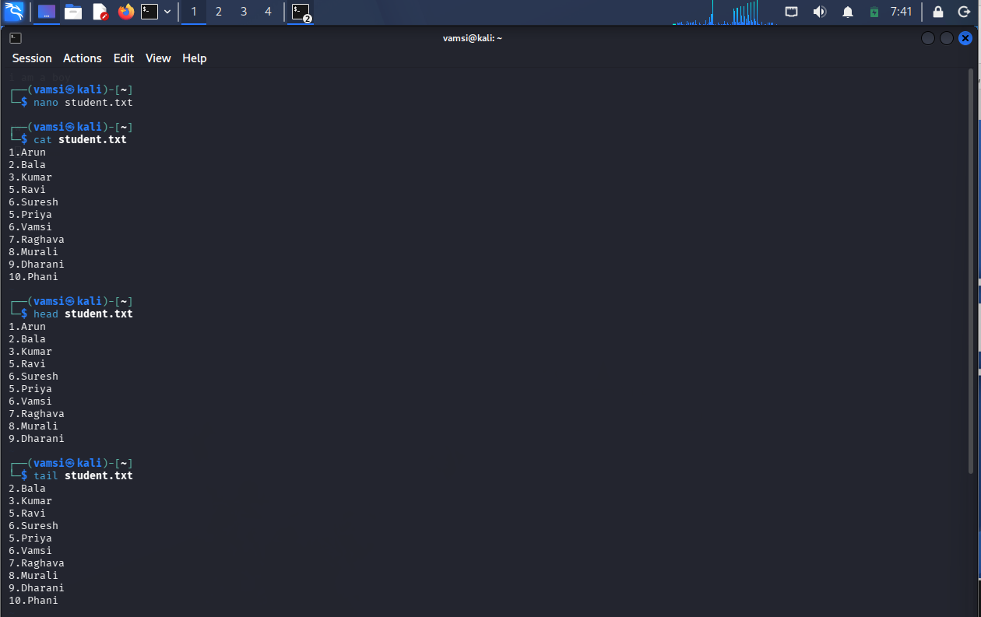
Result
Successfully executed tree, head, and tail commands.
